

ALLIANCE GIRLS 2025 PREDICTION
POSSIBLE KCSE EXAM
CHEMISTRY
233/1
(THEORY)
PAPER 1
TIME: 2 HOURS

NAME……………………………………………………………………………………….
SCHOOL……………………………………………… SIGN………………………..
INDEX NO……………………………………………. ADM NO……………………

Kenya Certificate of Secondary Education.

INSTRUCTIONS TO CANDIDATES
- Write your name and index number in the spaces provided above.
- Sign and write the date of examination in the spaces provided above.
- Answer ALL the questions in the spaces provided.
- Mathematical tables and electronic calculators may be used.
- All working MUST be clearly shown where necessary.

Questions | Maximum Score | Candidate’s Score
1 – 31 | 80
FOR EXAMINERS USE ONLY

- State and explain the observation made when excess ammonia gas reacts with chlorine gas. (2marks)
…………………………………………………………………………………………………
…………………………………………………………………………………………………
……………………………………………………………………………………………………………………………………………………………………………………………………
- Hydrogen gas reacts with ethene to form ethane. Calculate the volume of hydrogen required to convert 14g of ethene to ethane at S.T.P. (3 marks)
C₂H_{2 (g)} + H_{2 (g)} C₂H₆
(C = 12, H = 1, molar gas volume at S.T.P. is 22.4 litres)
……………………………………………………………………………………………………………………………………………………………………………………………………
……………………………………………………………………………………………………………………………………………………………………………………………………
- The table below shows the relative molecular masses and boiling points of propan-l-ol and
Ethanoic acid.
 | Relative Molecular Mass | Boiling point (ºC)
Propan –l-ol | 60 | 36
Ethanoic acid | 60 | 118

Explain why the boiling point of Ethanoic acid is higher than that of propan –l-ol and yet they have same molecular mass. (2 marks)
……………………………………………………………………………………………………………………………………………………………………………………………………
……………………………………………………………………………………………………………………………………………………………………………………………………
4. In an experiment an equal amount of iron fillings and sulphur powder was heated in a test tube. The mixture was left to cool then dilute hydrochloric acid added to it.
a) State the observations that were made;
(i) In the test tube. (1 mark)
……………………………………………………………………………………………………………………………………………………………………………………………………
(ii) Dilute hydrochloric acid was added to the mixture after cooling. (1 mark)
……………………………………………………………………………………………………………………………………………………………………………………………………
b) Write an equation for the reaction which occurred in a) (ii) above. (1 mark)
…………………………………………………………………………………………………

5. a) What is meant by double decomposition? (1 mark)
……………………………………………………………………………………………………………………………………………………………………………………………………
b) Starting with 1M sodium sulphate solution, describe how you would prepare dry lead II
sulphate. (2 marks)
…………………………………………………………………………………………………………………………………………………………………………………………………………………………………………………………………………………………………………………………………………………………………………………………………………
6. 6.84g of aluminium sulphate were dissolved in 200cm³ of water. Calculate the Molar
concentrations of the sulphate ions in the solution.(Relative formula mass of aluminium
sulphate is 342) (3 marks)
……………………………………………………………………………………………………………………………………………………………………………………………………………………………………………………………………………………………………………………………………………………………………………………………………………………………………………………………………………………………………………
7. The diagram below shows the set-up that was used to prepare and collect sulphur (iv) oxide gas.
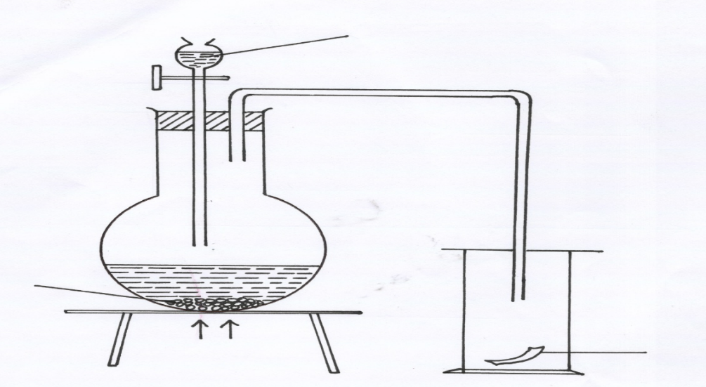
Hydrochloric acid

Solid P
moist red flower
Heat

(a) Identify solid P (1 mark)
…………………………………………………………………………………………………..
(b) (i) Why is it possible to collect sulphur (IV) Oxide as shown? (1 mark)
…………………………………………………………………………………………………………
…………………………………………………………………………………………………………
(ii) What happened to the red flower. (1 mark)
…………………………………………………………………………………………………………

8. The set-up show how small pieces of red phosphorous are heated in Nitrogen (I) Oxide.
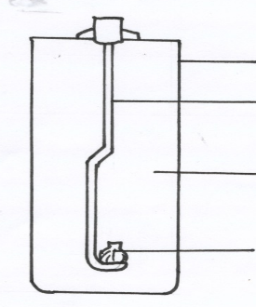
Gas jar
Deflagrating spoon
Nitrogen (I) oxide

Burning Phosphorous

a) Write an equation for the reactions which occur in the gas jar. (1 mark)
…………………………………………………………………………………………………..
b) Give one use of Nitrogen (I) oxide. (1 mark)
…………………………………………………………………………………………………..

9. Study the following reactions scheme and answer the questions that follow.
SOLUTION C
Drops of NaOH _{(aq)}
Drops of NH_{3 (aq)}

White ppt. D
White ppt. E

Excess NaOH _{(aq)}
Excess NH_{3 (aq)}

Colourless solution F
Colourless solution G

a) Identify
(i) The cations in solution C. (1 mark)
……………………………………………………………………………………..…………
(ii) The white precipitate E. (1 mark)
…………………………………………………………………………………………………
b) Why does precipitate E dissolve in excess sodium hydroxide solution. (1 mark)
……………………………………………………………………………………………………………………………………………………………………………………………………
c) Write the formula of the complex ion formed. (1 mark)
……………………………………………………………………………………………………………………………………………………………………………………………………
10. Starting with copper metal, describe how a sample of crystals of copper (II) sulphate is
prepared in Laboratory. (3 marks)
…………………………………………………………………………………………………………………………………………………………………………………………………………………………………………………………………………………………………………………………………………………………………………………………………………
11. The Set up below shows an experiment where hydrogen gas was passed over heated copper (II) Oxide.
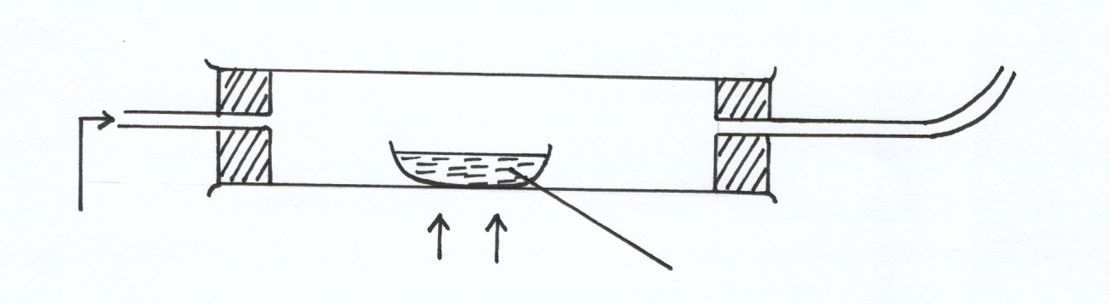
Copper (II) oxide
Dry hydrogen
Heat

a) State and explain the observations made in the combustion tube during the
experiment. (3 marks)
……………………………………………………………………………………………………………………………………………………………………………………………………
……………………………………………………………………………………………………………………………………………………………………………………………………
b) Explain why heat is necessary in this experiment. (1 mark)
……………………………………………………………………………………………………………………………………………………………………………………………………
12. a) State Boyle’s law (1 mark)
……………………………………………………………………………………………………………………………………………………………………………………………………
b) 3 litres of oxygen gas at one atmosphere pressure were compressed to two atmospheres at constant temperature. Calculate the volume occupied by the oxygen gas . (2 marks)
………………………………………………………………………………………………………………………………………………………………………………………………………………………………………………………………………………………………………
13. The table below gives some information about elements J,K,L,M which are in the same group of the periodic table. Use the formation to answer the question that follow.
Element | 1st Ionization energy kJmol-1 | Atomic radius (nm)
J  K  L  M | 520  500  420  400 | 0.15  0.19  0.23  0.25
- What is meant by ionization energy. (1 mark)
……………………………………………………………………………………………………………………………………………………………………………………………………………………
- State and explain the relationship between the variations in the first ionization energies and the atomic radii. (2 marks)

…………………………………………………………………………………………………………
…………………………………………………………………………………………………………
…………………………………………………………………………………………………………
…………………………………………………………………………………………………………

14. When a hydrocarbon fuel burn, one of the main products is acidic gas R.
(a) Identify gas R. (1 mark)
…………………………………………………………………………………………………………
(b) What effect does gas R have when its concentration in the atmosphere exceeds its acceptable levels. (1 mark)
………………………………………………………………………………………… …………………………………………………………………………………………
15. The graph below shows a curve obtained when water at 22ºC was heated for 10 minutes.
Sodium Chloride crystals were added and strongly heated for 15 minutes.
| | | | | |
0 5 10 15 20 25 30
22ºC
100ºC-
120ºC-
Time (min)

C
B
Temperature
ºC
A

a) What happened to water molecules between points A and B? (1 marks)
……………………………………………………………………………………………………………………………………………………………………………………………………
b) Explain why the temperature rise is not steady between points B and C. (2 marks)
………………………………………………………………………………………………………………………………………………………………………………………………………………………………………………………………………………………………………
16. Use the table below to answer the questions that follow.
Substance | A | B | C | D | E
Symbol | R-COO-Na⁺ | CH₂OH  |  CHOH  |  CH₂OH | --CH₂ – CH₂ –  n | R-COOCH₂  |  R- COOCH  |  R- COOCH₂ | R-OSO₃-Na⁺
- Which substances is:
I ) A soapless detergent. (½ mark)
…………………………………………………………………………………………
II) An ester (½ mark)
…………………………………………………………………………………………
b) Give name to substance B. (1 mark)
………………………………………………………………………………………………… …………………………………………………………………………………………………
c) Write an equation for the reaction between the structure of substance D and Sodium hydroxide solution. (2 marks)
……………………………………………………………………………………………………………………………………………………………………………………………………

17. When hydrated sample of iron (II) sulphate FeSO₄.nH₂O was heated until there was no further change in mass, the following data was recorded
Mass of evaporating dish = 78.94 g
Mass of evaporating dish + hydrated salt = 84.14 g
Mass of evaporating dish + residue = 81.78 g
Determine the empirical formula of the hydrated salt. (Relative Formula Mass of FeSO₄ = 152, H₂O = 18) (3 marks)
……………………………………………………………………………………………………….……………………………………………………………………………………………
……………………………………………………………………………………………………….……………………………………………………………………………………………
18. Study the flow chart below and answer the questions that follow;
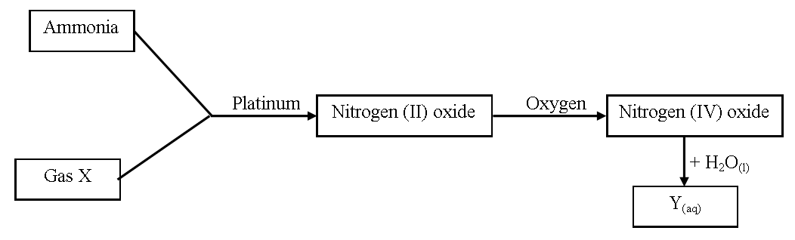
(a) Write an equation for the reaction between gas X and ammonia. (1 mark)
………………………………………………………………………………………… …………………………………………………………………………………………
(b) Write the formulae of the substances present in the mixture Y_{(aq)}. (1 mark)
…………………………………………………………………………….……………………………………………………………………………………………………………………….
19. When hydrogen sulphide gas was bubbled into an aqueous solution of iron (III) chloride, a yellow precipitate was deposited.
(a) State another observation that would be made. (1 mark)
………………………………………………………………………………………… ………………………………………………………………………………………… …………………………………………………………………………………………
(b) Write an equation of the reaction that took place. (1 mark)
………………………………………………………………………………………… …………………………………………………………………………………………
20. The table below shows the atomic numbers of elements P, Q and R.
Element | P | Q | R
Atomic | 13 | 7 | 12

(a) Explain why P and R would not be expected to form a compound. (1 mark)
………………………………………………………………………………………… ………………………………………………………………………………………… ….………………………………………………………………………………………
(b) Write an equation to show the effect of heat on the carbonate of R. (1 mark)
…………………………………………………………………………………………
21. Element T consists of two isotopes ⁶²T and ⁶⁴T in the ratio 7 : 3 respectively. Calculate the relative atomic mass of element T. (3 marks)
……………………………………………………………………………………………………….…………………………………………………………………………………………………………………………………………………………………………………………………………………………………………………………………………………………………

22. Name the process which takes place when:
(a) Solid carbon (IV) oxide changes directly into gas. (1 mark)
………………………………………………………………………………………… …………………………………………………………………………………………
(b) An alcohol reacts with alkanoic acid in the presence of sulphuric acid to form a sweet
smelling compound. (1 mark)
………………………………………………………………………………………….
23. Briefly explain how you would obtain pure sample of lead (II) chloride from a mixture of lead (II) chloride and silver chloride. (2 marks)
……………………………………………………………………………………………………….…………………………………………………………………………………………………………………………………………………………………………………………………….……………………………………………………………………………………………
24. Explain the following observations; very little carbon (IV) oxide is evolved when lead carbonate reacts with dilute hydrochloric acid. (2 marks)
……………………………………………………………………………………………………….…………………………………………………………………………………………………………………………………………………………………………………………………….……………………………………………………………………………………………
25. The table below gives some properties of compounds P, Q, R and S
Compound | B.P. (ºC) | M.P. (ºC) | Conductivity in water
P | 77 | -23 | Does not conduct
Q | 74 | -19 | Does not conduct
R | -161 | -185 | Conducts
S | 2407 | 714 | Conducts
(a) Which one of the compounds in the table is ionic? Explain. (1 mark)
………………………………………………………………………………………… …………………………………………………………………………………………
(b) Give the compound that is liquid at room temperature. (1 mark)
…………………………………………………………………………………………
26. When butan – 1 – ol is oxidized by acidified potassium dichromate, a weak organic acid is formed.
Draw and name the structural formula of the acid obtained from the above reaction.(2 marks)
…………………………………………………………………………………………………………………………………………………………………………………………………………………………………………………………………………………………………………………………………………………………………………………………………………………………………………………………………………………………………………………………………………………………………………………………………………………………………………………………………………………………………………………

27. Air was passed through several reagents as shown in the flow chart below.
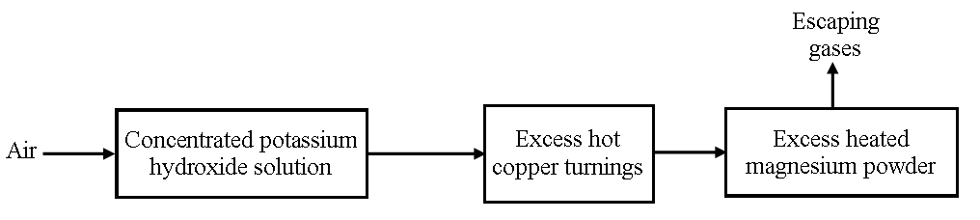
(a) Write an equation for the reaction that took place in the chamber with the magnesium
powder. (1 mark)
………………………………………………………………………………………… …………….……………………………………………………………………………
(b) Name one gas that escapes from the chamber containing magnesium powder. Give a
reason for your answer. (1 mark)
………………………………………………………………………………………… …………………………………………………………………………………………
28. A sisal farmer found that when pricked by a sisal thorn, application of a little solution of ash
helped to relieve the pain from the affected area. Explain. (2 marks)
……………………………………………………………………………………………………….……………………………………………………………………………………………

29. Explain why aluminium metal is not extracted from aluminium chloride. (2 marks)
……………………………………………………………………………………………………….……………………………………………………………………………………………………………………………………………………………………………………………….

30. Distinguish between a strong acid and concentrated acid. (2 marks)
………………………………………………………………………………………………… …………………………………………………………………………………………………
………………………………………………………………………………………………… …………………………………………………………………………………………………

31. In an experiment to determine the solubility of potassium nitrate at 30ºC, a saturated solution was heated in an evaporating dish until there was no further change in mass. The following data was obtained.
Mass of dish + solution = 128.9 g
Mass of dish + dry salt = 103.9 g
Mass of empty dish = 94.3 g
Determine the solubility of potassium nitrate at 30º C. (3 marks)
……………………………………………………………………………………………………….……………………………………………………………………………………………
……………………………………………………………………………………………………….………………………………………………………………………………………………………………………………………………………………………………………………..

